Declaration 🡪 A declaration introduces a new identifier (such as a variable, function, or class) and defines its type **without necessarily allocating memory or assigning a value.**   
  
**Definition 🡪** definition refers to the part of the code where the characteristics and properties of an identifier are **fully specified**.  
  
**Declaration Vs Definition**

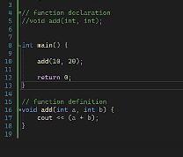  
  
**Call Stack /Call Hierarchy 🡪** is a data structure used by computer programs to keep track of function calls and their execution context**. (i** **t operates in a "last in, first out" (LIFO) manner)**

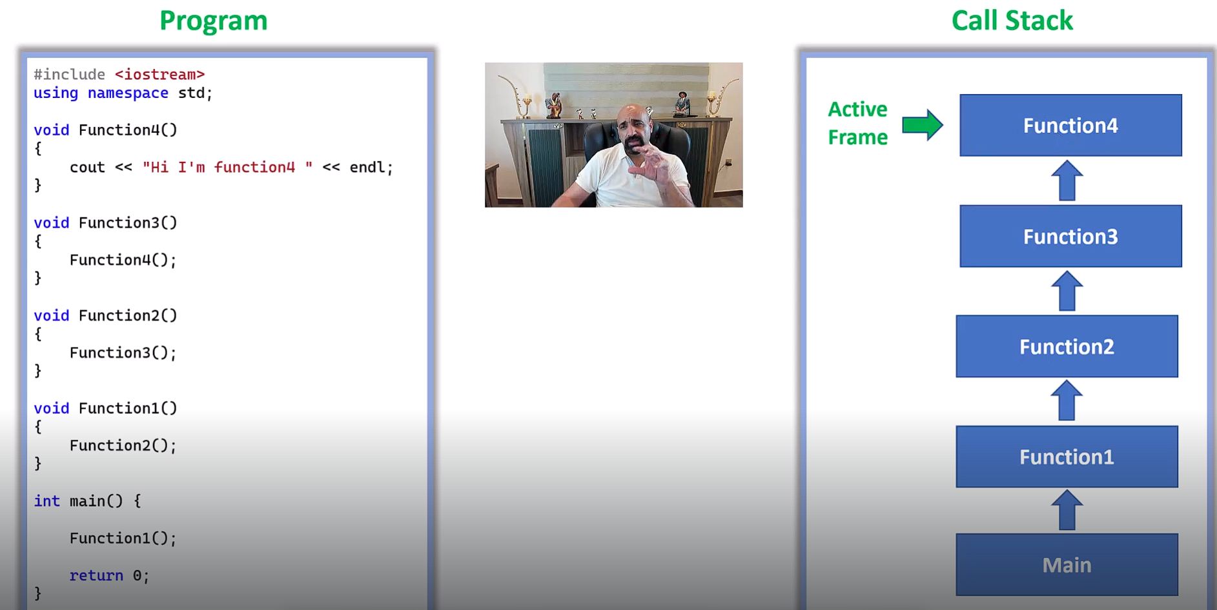

**Register Variable 🡪** is a special type of variable in programming languages like C and C++ that is **stored in the CPU's register** rather than in the main memory (RAM)**. Faster but so sensitive**

**# OOP #  
  
Encapsulation 🡪** In Object Oriented Programming, Encapsulation is defined as **binding together the data and the functions that manipulates them.  
  
  
  
  
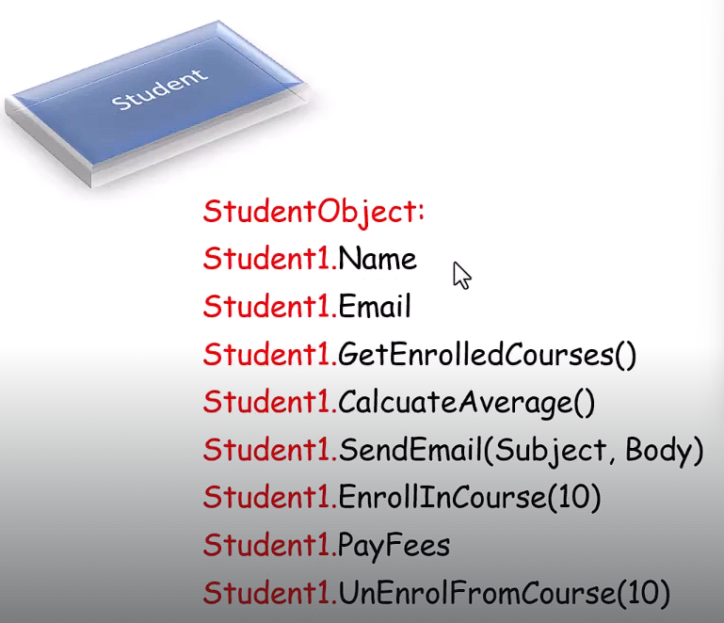  
  
Abstraction🡪** Abstraction “displays” **only the relevant attributes of objects and “hides” the unnecessary details.**

**Function Overriding🡪**  The function in derived class overrides the function in base class.(using **Inheritance**)

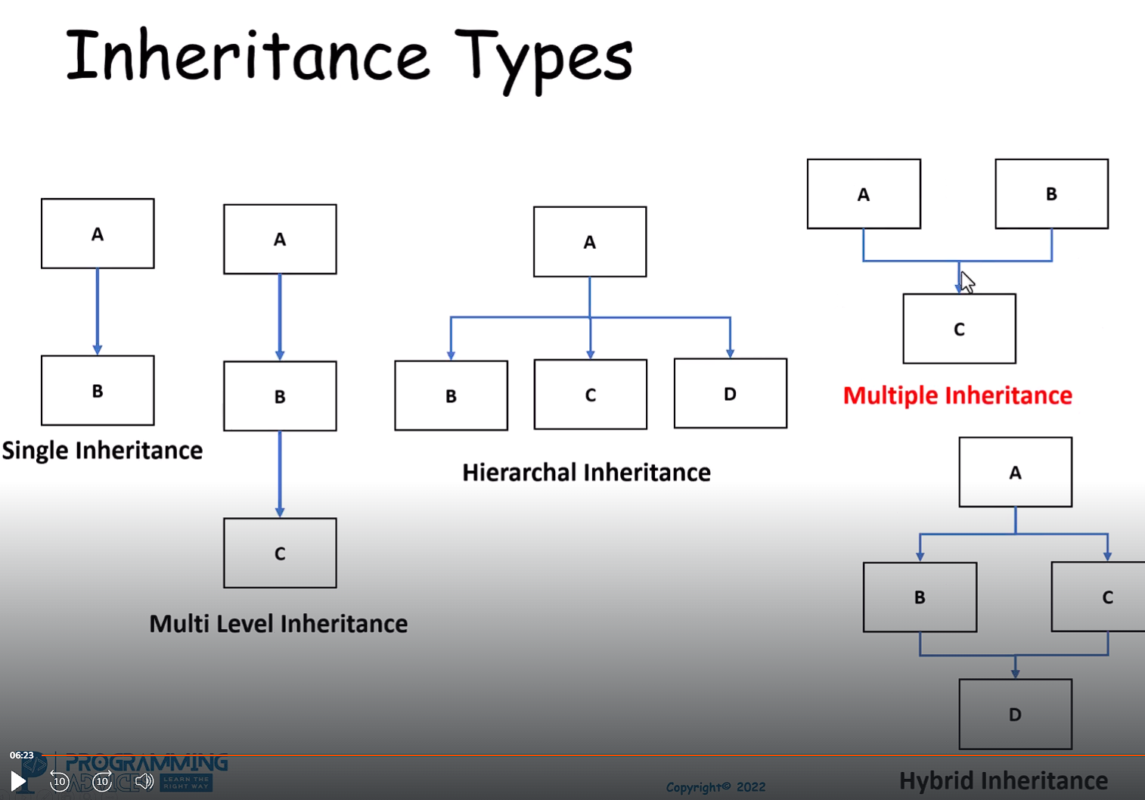

Up Casting /Down Casting

Up Casting 🡪SubClass To Base Class  
Down Casting 🡪 Base Class To SubClass (U cant)

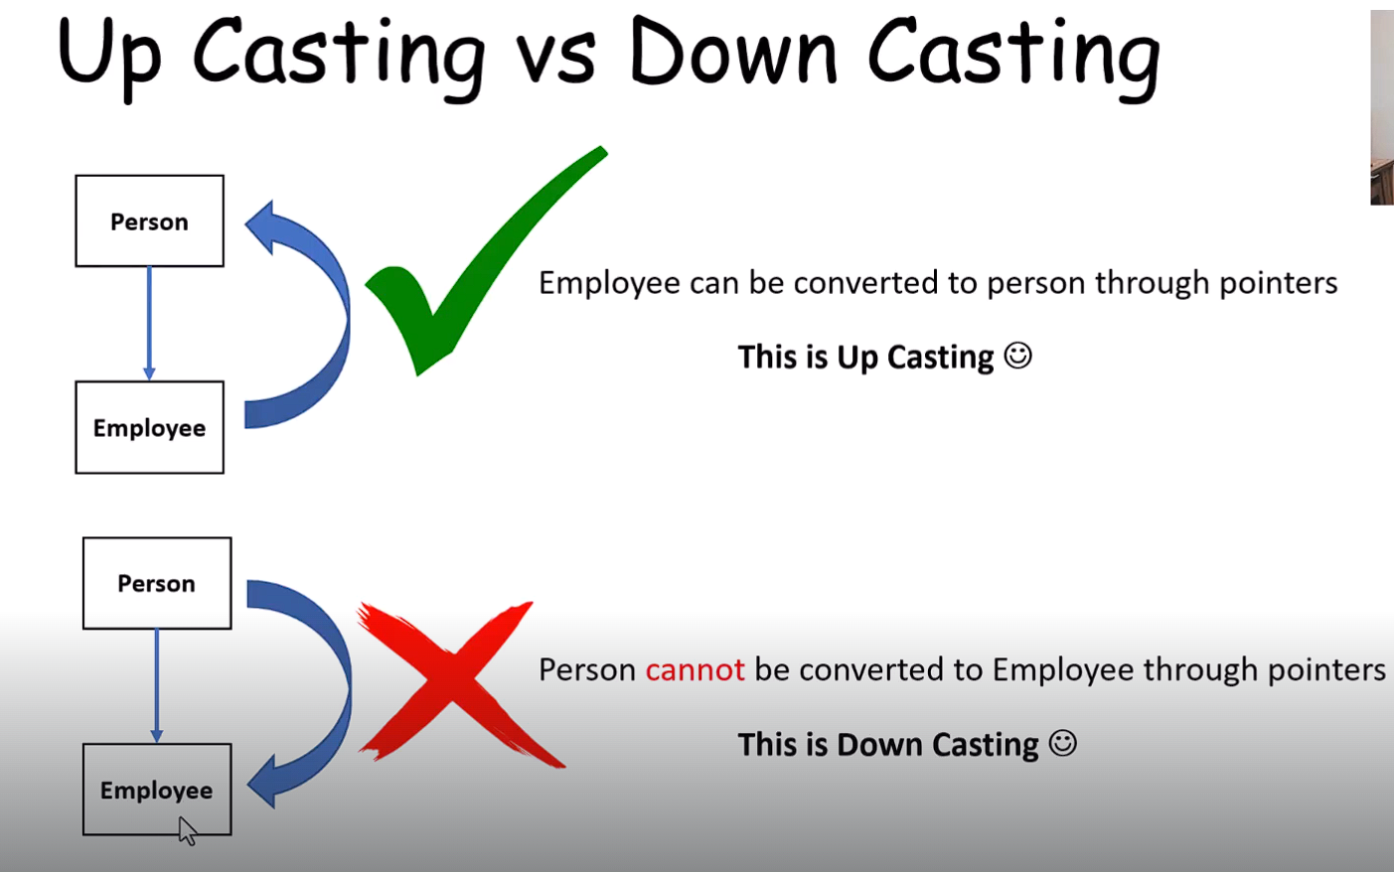

**Virtual Functions 🡪** it means that the function will be overridden by childrens, so mr.Compiler I'll Point to Derived class, print the function of it, not the original one in the base class.   
  
Here Person,employee and studant classes have a Overrided Function (Called Print)   
when We Make The Print Fun in the Base Class(Person ) A Vitual That means use the print on the pointed class   
يعني جيبلي الفانكشن اللي مأشر عليه  
  
  
  
**Static/Early Binding vs Dynamic/Late Binding**

**Static/Early Binding 🡪** the method or function to be called **is determined at compile time**, rather than at runtime. (**the program knows exactly which function to use and prepares everything in advance before you start the work.)  
  
Dynamic/Late Binding 🡪** the method or function to be called **is determined at runtime**, rather than at compile time.( **the program waits until it's running to decide which method to use, based on the actual type of the object.)**

**Polymorphism 🡪 “Many Forms” .allows us to create consistent code.**

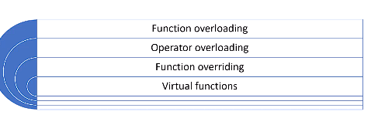 **Pure virtual function Interface 🡪** function declared in a base class that has no implementation in that base class. It is meant to be overridden by derived classes

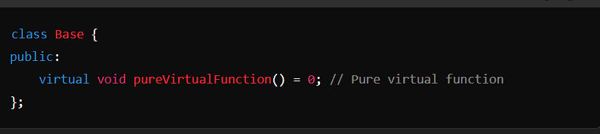

**Abstract Class🡪 A class that Contains at least one pure virtual function** And i**ts essential**

**For Other Classes.  
  
Friend Classes 🡪** A friend class **can access both private and protected members** of the **class in which it has been declared as friend.**

**Friend Function 🡪** A friend function in C++ **is defined as a function that can access private, protected and public members of a class.**